- The following parts appear on the V2 PCB but are NOT in the Pick & Place list. We need to make sure they are listed on the v3 list.
Please provide details on each: J26, R25, Q1, and the part near the label “fan” on the part it says “429 RS1B”.
(J23 is missing from list but has been identified, no need to clarify.)
Please see the attached photo. Can you identify what part goes in each location shown?
Okay, I can see J26, R25 and Q1 in the BOM and in Pick Place file. Check the attached BOM and PNP files.
J26 – Fan cable connector will connect with J26
R25 - Res Thick Film 1206 8.2K Ohm 1% 0.25W(1/4W) ??100ppm/C Pad SMD T/R
Q1 - DMG1012UW-7
- V3 change: Remove J12 and the extra space reserved for a future MQ sensor. There is a second empty space at J1 remove that.
- V3 change: Remove the ZE-03 SO2 sensor and all its associated connections. At $215 per unit it is no longer worth including.
- V3 change: Fix the MQ-06 silkscreen label — the text is printed over itself and is unreadable.
- V3 change: Increase the spacing between J24 and J25 by 1mm. They are currently too close and connectors are difficult to plug in.
- V3 change: Every single component on the board must have a clear readable label on V3. On V2 it took 2 hours to find and confirm each part.
I will send a separate list of all currently unlabeled parts. Please make sure nothing is missed.
- V3 change: None of the capacitors C1–C11 are labeled on the V2 board. All must be labeled on V3.
Okay got it.

What goes in the big square and the small square?
As Oleksii told me that he will 3D print a frame to attach a fan on it. So I make a place to attach a fan.
These all have no label and we need to make sure they have labels on V3 R5, C1-C11, R1-R11
Okay got it.

Please tell me what is the function of the potentiometers at R17-R19?
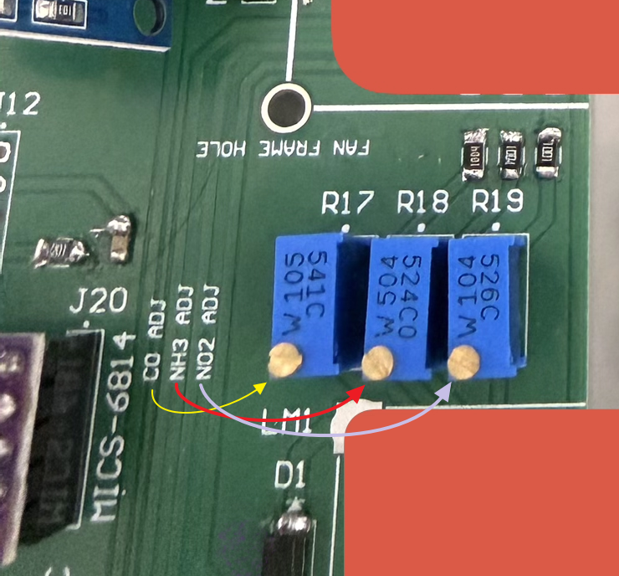
As you can see the label, these pots are used to adjust values of CO, NH3 and NO2 from
MICS-6814 sensor.

Will I use the jumper connections at j23,j19,j21?
J23 – No need to use. I just used it for extra precaution.
J19 – Yes, Use this jumper to power up the Arduino board. I place this jumper because some times you may just want to power up Arduino with only USB cable from PC. But you can always use this jumper.

J21 - Do not need to use J21

What connects to the socket at j14?
J14 - AMASS_XT30PW-M .

On v2 there is only one socket for one fan. Make sure to have 2 sockets on v3. I will use 2, 40mm fans
Okay got it.

Why do we have the second set of holes at J 22?
Just to indicate the sensor size. No use for these holes.

